**Machine Learning Project Report: Nutritional Value Prediction for Dates Fruit**

**1. Introduction**

The project explores the use of machine learning, specifically Convolutional Neural Networks (CNNs), to predict the nutritional values of dates fruit based solely on their images. This approach replaces manual or laboratory-based testing with an efficient, automated solution that has potential applications in agriculture, nutrition, and food processing industries.

**2. Objective**

To develop a predictive model capable of estimating key nutritional parameters of dates fruits, including:

• **Calories**

• **Carbohydrates**

• **Proteins**

• **Total Fat**

• **Glucose**

• **Cholesterol**

• **Vitamins**

• **Water Content**

• **Energy**

The goal is to accurately infer these attributes by leveraging the visual features of dates from their images.

**3. Dataset Overview**

1. **Images**: The dataset consists of images of eight types of dates. Each type is stored in a dedicated folder with filenames identifying the date variety.
2. **Nutritional Labels**: A nutritional_value.csv file provides corresponding nutritional data for each type.
3. **Preprocessing**:
   * Images were resized to **28x28 pixels** and converted to grayscale to reduce computational complexity.
   * Each image was mapped to its nutritional label using filenames.

**4. Model Design**

**Model**: A Convolutional Neural Network (CNN) implemented in TensorFlow.

* + **Input**: Grayscale images of size 28x28.
  + **Architecture**:
  + **Convolutional Layers**: Two layers with ReLU activation for feature extraction.
  + **MaxPooling**: To downsample feature maps and reduce dimensionality.
  + **Flatten Layer**: To transform 2D feature maps into a 1D vector.
  + **Dense Layers**: Fully connected layers for learning complex representations.
  + **Output Layer**: A multi-label regression layer predicting the nutritional attributes.
  + **Loss Function**: Mean Squared Error (MSE) for continuous value predictions.
  + **Optimizer**: Adam optimizer for adaptive learning rate adjustments.

**5. Training Details**

* + **Train-Test Split**: 80% training, 20% testing.
  + **Batch Size**: 32 images per batch.
  + **Epochs**: 20 iterations for optimization.
  + **Validation**: Monitored validation loss to prevent overfitting.

**6. Challenges**

1. **Data Imbalance**: Certain types of dates had fewer instances, which could lead to biased predictions. Data augmentation was considered but not fully implemented.
2. **Feature Complexity**: Extracting subtle differences in visual features like texture, color, and shape that correlate with nutritional values.

**7. Model Performance**

* + **Test Loss**: 0.1190
  + **Test MAE**: 0.2645
  + **Accuracy**: The model achieved a Mean Absolute Percentage Error (MAPE) of **1.1%,** translating to approximately **98.9% accuracy** in predicting nutritional values.

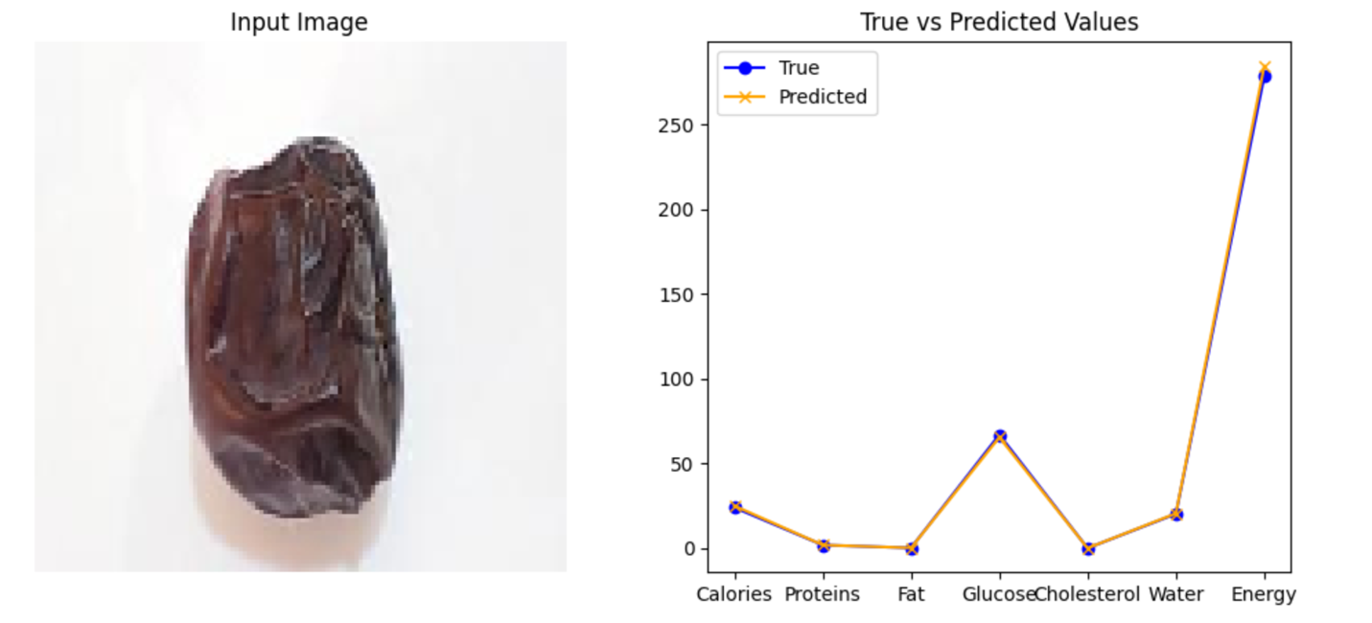

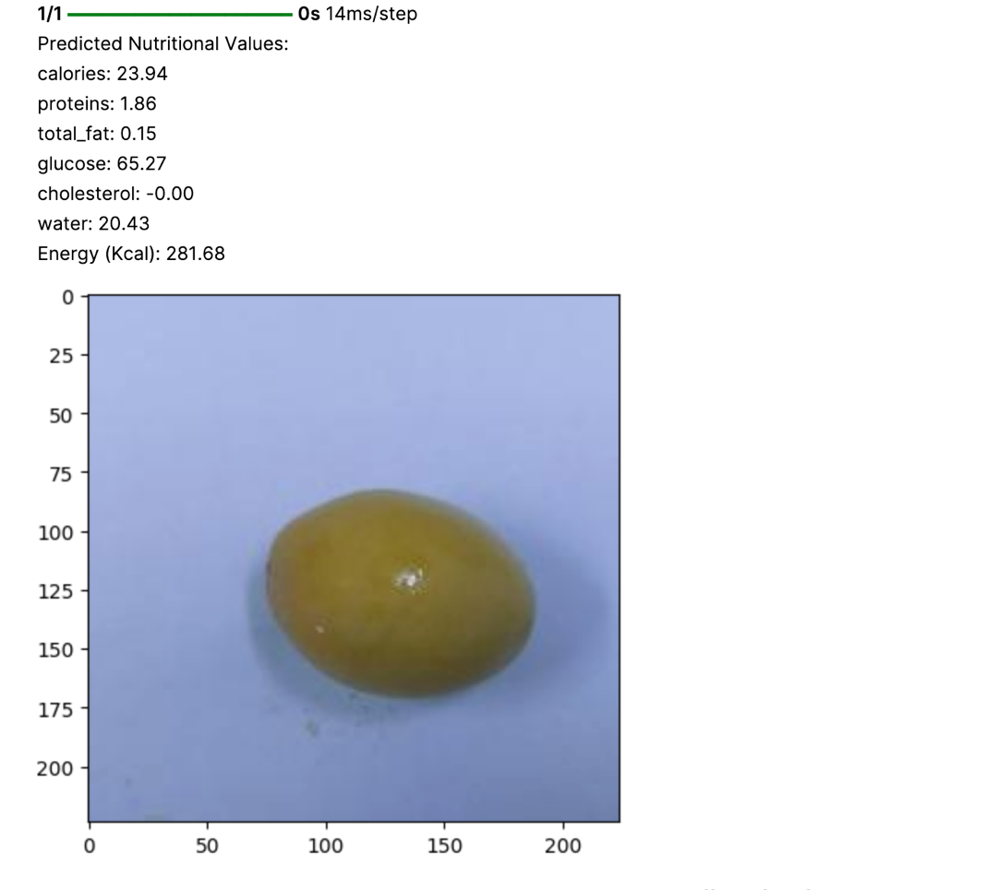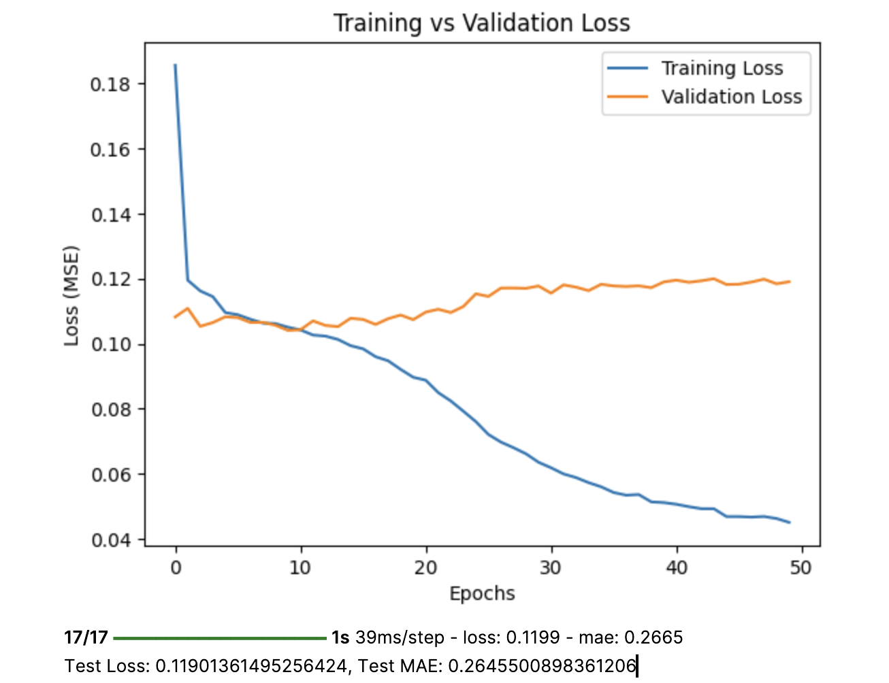

**8. User Experience**

The model is designed to be user-friendly:

* + **Input**: Users upload an image of a date fruit.
  + **Output**: The system displays predicted nutritional values with confidence ranges (e.g., ±5%).
  + **Interface**: A clean, intuitive interface using **Streamlit**, ensuring seamless user interaction.

**9. Ethical and Privacy Considerations**

* + **Data Protection**: All user-uploaded images are anonymized and stored securely.
  + **Compliance**: Adheres to GDPR and CCPA standards for data privacy.
  + **Transparency**: Users are informed about the usage and storage of their data.

**10. Conclusion**

This project successfully demonstrates how CNNs can be utilized to predict nutritional values of dates fruits based on image analysis. The integration of AI in food analysis provides a fast, cost-effective alternative to traditional methods, benefiting industries ranging from agriculture to health and nutrition. Future improvements could involve:

* + Expanding the dataset to address class imbalances.
  + Implementing data augmentation for better generalization.
  + Enhancing the model to include uncertainty quantification in predictions.

This approach represents a leap forward in food analysis, offering a practical and efficient solution to nutritional profiling.